COVIDSafe Plan

Guidance on how to prepare your COVIDSafe Plan is available here.
Our COVIDSafe Plan
Business name: St Johns Regional College
Site location: Dandenong
Contact person: Greg Van Es
Contact person phone: 8793-2000
Date prepared: 01/11/2021
Where applicable, guidance on specific controls for essential VCE and VCAL assessments can be found on page 8.
This document is to be used in conjunction with the current School Operations Guide, and is designed to document the operational details and specific controls for school’s COVID-19 response.
This is a live document which should be regularly updated to reflect the school’s current COVIDSafe practices in line with the Victorian Government’s health advice and current School Operations Guide.
Document current as of 1 November 2021, with updated guidance in green font.
Guidance | Action to mitigate the introduction and spread of COVID-19
Hygiene
Provide and promote hand sanitiser stations for use on entering buildings and other locations in the worksite, and ensure adequate supplies of hand soap and paper towel are available for staff. | - Infrastructure to ensure an adequate supply of hand sanitiser, liquid soap, paper towel and disinfectant is available. Each building should have hand sanitiser and disinfectant wipes provided in entrances and occupied rooms.  - Supply is being checked at the start and end of each day.  - Cleaning contractor arrangements to include COVIDSafe daily end-of-school-day routine cleaning of all buildings’ surfaces, with a focus on high-touch surfaces using a hospital-grade disinfectant.  - Staff are being reminded to carefully place all paper towels, wipes and disposable personal protective equipment (PPE) in bins for cleaners to collect.  - Bin liners are being replaced daily or as required and, if reused, disinfected.  - Information has been provided to staff on washing hands or using hand sanitiser before and after moving between rooms or buildings, and after touching any doors.  - Infrastructure to ensure an ample supply of > 60% alcohol-based hand sanitiser is available.  For more information: Infectious Cleaning Guidelines.
Where possible, enhance airflow by opening windows, adjusting air conditioning and installing air purification devices. | - Air purifiers are advised to be prioritised for higher risk areas. These areas include where high levels of mixing of staff and reduced mask use when eating, higher levels of exertion and increased aerosol projection, and areas of lower ventilation and possible exposure to illness. For example, sick bays, staff rooms, canteens, school receptions and student centres, gymnasiums and music rooms.  - Turn on mechanical ventilation, where available and practicable, is to run systems during school hours including when rooms are unoccupied, and if possible ideally 2 hours before and after the use of a space. Where available, timers can be used to manage operation.  - Air recirculation should be eliminated or minimised by setting air conditioning units to use external air rather than recycling, where possible.  - Demand-controlled ventilation controls that reduce air supply based on occupancy or temperature should be disabled.  - Air conditioning filters should be maintained according to maintenance plans, checked and cleaned with appropriate PPE.  - Group activities have been rearranged to occur outdoors or in large indoor spaces where possible.  - Staff are being encouraged to open windows and doors to promote airflow where possible.  - Heating/split system filters are being cleaned on a regular basis to reduce the risk of airborne transmission.  - Air conditioning systems have been set to use fresh air.  - Not all mechanical systems can operate using outside air (for example, most split systems). Air conditioners that are unable to bring in outside air should not be considered as providing mechanical ventilation.  - Air conditioners may be used to provide thermal comfort, however if they cannot use outside air, then they need to be used with other ventilation strategies.  - Aim to open windows and vents that are higher or towards the ceiling during poor or windy weather.  - Keep exhaust fans are to be used as much as possible.  - Take measures to maintain thermal, noise and other comfort, such as flexible uniform and seating arrangements.  - Schools are encouraged to avoid or reduce the use of spaces that can’t be ventilated with fresh outdoor air, including spaces with windows that don’t open or open to environments with poor air quality or other pollutants. Rotate the use of spaces that can be well ventilated if required.  - Using more than one ventilation method creates greater opportunity to create a comfortable learning environment and maximising ventilation.  For more information: School Operations Guide.
In areas or workplaces where it is required, ensure all staff wear a face covering and/or required PPE, unless a lawful exception applies. Ensure adequate face coverings and PPE are available to staff who do not have their own. | For all school settings, the Victorian Chief Health Officer:  - Directs school staff and secondary school students to wear a face mask indoors at school, including Outside School Hours Care (OSHC) programs, unless a lawful exception applies.  - Directs primary school students in Year 3 and above to wear a face mask indoors at school, including Outside School Hours Care (OSHC) programs, unless a lawful exception applies. Face masks can be removed while outdoors at school.  - For composite classes that include students in and above Grade 3 and below Grade 3, those below Grade 3 are strongly encouraged to wear masks.  - Directs school staff and students aged 12 or older must always wear a face mask when travelling to and from school on public transport, taxis or ride share vehicles.  - Directs school staff to wear a face mask while teaching wherever practicable, except where removal of a face mask is necessary for effective communication.  - Strongly recommends students in Prep to Grade 2 to wear a face mask indoors at school or OSHC program.  - Strongly recommends school students aged under 12 to wear a face mask when travelling to and from school on public transport, taxis or ride share vehicles.  Outside of lawful exemptions, schools must treat any deliberate and persistent non-compliance with the face masks direction as a serious matter. Usual school procedures for dealing with non-compliance of staff with school rules should be followed.  A face mask must cover the nose and mouth. Face shields, scarves or bandanas do not meet these requirements. Schools will be provided with a supply of face masks that meet the above requirements to provide to students and staff should they be needed.  For more information: DHHS guidance on face masks.
Provide training to staff on the correct use and disposal of face coverings and PPE, and on good hygiene practices and slowing the spread of coronavirus (COVID-19). | All staff are being briefed on infection control precautions:  - Avoid people with fevers, sweats, chills or flu-like symptoms.  - Use hand sanitiser between classes and after contact with commonly touched surfaces.  - Maintain good cough etiquette.  - Do not touch, kiss or hug others.  - Use disinfectant wipes to clean computers and desks between different users and at the end of the day.  - If a person has been advised by the DHHS that they are considered a ‘close contact’ of someone with a confirmed case of COVID-19, they must:  - notify the school or office, self-isolate and arrange to be tested  - not return to work until test results are obtained.  The DHHS will notify the school if a student is identified as a close contact of a person with COVID-19. The school will:  - liaise with the DHHS to confirm the student identified as a close contact is not attending school during quarantine and testing requirements  - send the student home if they are attending school.  For more information: School Operations Guide.
Replace high-touch communal items with alternatives. | Progressive cleaning of high-touch surfaces throughout the school day is no longer required, noting that schools have in place a range of complementary COVIDSafe strategies to reduce transmission risk. Schools should continue COVIDSafe routine and enhanced environmental cleaning and disinfection.  For more information:  - School Operations Guide.  - Infectious Cleaning Guidelines.
Cleaning
Increase environmental cleaning (including between changes of staff), and ensure high-touch surfaces are cleaned and disinfected regularly (at least twice daily). |  |  | Progressive cleaning of high-touch surfaces throughout the school day is no longer required, noting that schools have in place a range of complementary COVIDSafe strategies to reduce transmission risk. Schools should continue COVIDSafe routine cleaning and ensure:  - Staff are being informed of the enhanced contractor cleaning arrangements and cleaning products.  - Staff are being encouraged to regularly wipe down commonly touched surfaces with disinfectant wipes between classes.  Deep Cleaning  Schools should close spaces that are not needed and only use the administrative and teaching spaces needed to maintain physical distancing requirements and effective learning conditions.  To help us deliver any necessary deep cleaning, it's recommended that school staff working on site:  - keep desks neat and tidy  - file important documents before leaving each day  - take personal belongings home each day (such as jackets, shoes, hats, gloves and face masks)  - do not leave food or food containers out in the open (such as tea bags, biscuits, fruit, used cups, used cutlery)  - store away shared and loose items (such as toys, musical instruments, and sporting equipment)  - keep personal cutlery in a sealed container, not left out on a workstation.  For more information:  - Infectious Cleaning Guidelines  - Enhanced School Cleaning Guidelines.
Ensure adequate supplies of cleaning products, including detergent and disinfectant. |  |  | - Cleaning contractor arrangements to include performing a thorough COVIDSafe routine clean of all buildings’ surfaces at the end of each day and/or increased frequencies using a hospital-grade disinfectant.  - Staff are being encouraged to carefully place all waste and disposable PPE in bins for cleaners to collect.  For more information: School Operations Guide.
Guidance | Action to mitigate the introduction and spread of COVID-19
Physical distancing and limiting workplace attendance
Establish a system to screen employees and visitors before accessing the workplace. Employers cannot require employees to work when unwell. |  |  | Directions on mandatory COVID-19 vaccination now apply to authorised workers, residential aged care workers, construction workers, workers in health care settings, school and early childhood staff. This includes principals, teachers, administration and education support staff, including casual relief teachers (CRTs) and pre-service teachers, as well as students undertaking Structured Workplace Learning and work experience  All staff who work in schools will be required to have a first dose of a COVID-19 vaccine by 18 October 2021 or be able to produce evidence of a vaccination booking within that week.  All staff are required to be fully vaccinated by 29 November 2021 unless a medical exemption applies. They will be required to show evidence of their vaccination status.  Density limits of one person per four square metres apply to staff areas such as staff lunchrooms and areas accessed by the public, such as reception areas.  Visitors to school grounds must comply with vaccination requirements, density limits, face mask requirements, QR code check-ins and practise respiratory etiquette and good hand hygiene.  The density limit of one person per four square metres should be applied to any spaces and activities being attended by parent/carers and other visitors. The density limit applies to all persons in the space, including students.  For public areas, signage must be displayed to indicate the maximum number of members of the public that may be present in the space at a single time.  Upon arrival at the campus or office, staff, students, visitors and contractors to be reminded to ‘stay home if unwell’. They will be asked to confirm if they or anyone at home have:  - experienced fever or flu-like symptoms, such as coughing, sore throat and fatigue  - experienced shortness of breath  - been in close contact with someone who has returned from overseas in the last 14 days  - been in close contact with someone with a confirmed case of COVID-19.  If upon arrival or during the day anyone exhibits COVID-19 symptoms, they will be immediately isolated. An incident report will be completed and the person encouraged to self-isolate until they can be tested and receive the result.  - Staff and visitors are being reminded to remain hypervigilant in maintaining good personal hygiene.  Return to school information  Please refer to appendix 1 for staged return to school information.  - For more information: School Operations Guide.  - https://www.education.vic.gov.au/school/Pages/coronavirus_swl.aspx
Establish a system for managing visitors and large events. |  |  | Visitors  Visitors to school grounds must comply with vaccination requirements, density limits, face mask requirements, QR code check-ins and practise respiratory etiquette and good hand hygiene.  The density limit of one person per four square metres should be applied to any spaces and activities being attended by parent/carers and other visitors. The density limit applies to all persons in the space, including students.  QR codes and record keeping  The use of Service Victoria QR codes for electronic record keeping is mandatory in all schools to enable the effective contact tracing of any COVID-19 cases.  QR code check ins are required to be used by:  - all essential visitors on school site (including contractors, external MACS staff and building and maintenance staff)  - all parents who enter school buildings when on school site for essential purposes  QR code check ins are not required to be used by:  - staff  - students  - parents of eligible students who come onto school grounds for drop off or pick up, but do not enter buildings.  Schools are reminded that existing sign in and out processes should continue to be used to record essential visitor attendance, in particular the purpose of visits, for legal and regulatory obligations  It continues to be recommended that staff should avoid working across multiple sites as much as practical, noting there will be some workforces who will need to work across multiple schools (i.e. health and wellbeing staff and casual relief teaching staff).  Professional development and staff meetings can resume, however online and remote options are still preferred where practicable.  Indoor events will remain subject to the obligations such as caps and density quotients. All eligible adults must be fully vaccinated.  Outdoor events can be held with up to 500 people, with a density quotient of one person per two square metres applied.  Consideration should be given to the management of visitors and large events when utilising shared facilities such as:  - Outdoor and indoor pools  - Playgrounds  - Sporting activities  - Camps and excursions  - Drinking facilities  - Professional development, etc.  Further information is available at:  https://www.coronavirus.vic.gov.au/victorian-government-qr-code-service  For more information: School Operations Guide.
Configure communal work areas so that there is no more than one worker per four square metres of enclosed workspace, and employees are spaced at least 1.5 metres apart. Also consider installing screens or barriers. |  |  | - Common rooms and areas accessed by the public (reception areas) in each campus or office will be inspected and seating arrangements staggered to promote physical distancing in line with one person for every four square metres.  - Floor marking will be introduced to maximise physical distancing.  - Staff and visitors are being reminded to remain hypervigilant in maintaining good physical distancing, at all times.  - Workstations, classrooms and reception areas will be reviewed and, wherever possible, reconfigured or modified to reduce the risk of person-to-person or person-to-surface transmission.  - Shields, barriers and signage will be considered as part of the control measures.  - Density limits do not apply in classrooms and other spaces for the purposes of student use, including corridors and other shared areas.  For more information:  - School Operations Guide  - Health and safety advice for all Victorian schools.
Minimise the build-up of employees waiting to enter and exit the workplace. |  |  | - Schools must implement actions to reduce the congregation of adults around the school and ease congestion. Schools can do this through strategies such as the use of multiple entry/exit points, creating spaces for egress in different areas of the school and appropriate signage to communicate expected behaviours.  - Schools must communicate the strategies in place to parents through local signage and school communications (e.g. letter and newsletter) to remind staff, students and families of the need for behaviours that support physical distancing.  - Stagger drop off and pick up times (noting operations of school hours should be not disrupted).  - Use of multiple entry and exit points to prevent concentrations of students and minimise parents onsite.  For more information: School Operations Guide.
Provide training to staff on physical distancing expectations while working and socialising (e.g. during lunchbreaks). |  |  | Staff and adult visitors are being briefed to follow physical distancing rules:  - Remain at least 1.5 metres from other individuals wherever possible.  - Only have one person in small work areas.  - Avoid shaking hands, hugging or touching others.  - Hold meetings outside in the open air if possible.  - Always use good hand and cough/sneeze hygiene.  - Eat lunch outside rather than indoors if possible.  - Don’t share food or drinks in the workplace.  - Practise the hygiene and cleaning protocols detailed in this plan.  - Staff should reduce as far as possible the use of common areas such as staff rooms.  - Staff should eat and drink outside wherever possible and practicable.  - Density limits of one person per four square metres apply to staff areas such as staff lunchrooms and areas accessed by the public, such as reception areas.  All staff on site are trained in the ‘School and Early Childhood Infection Prevention and Control During Coronavirus (COVID-19)’ eLearn module.  For more information: Guidance on hygiene and physical distancing.
Review delivery protocols to limit contact between delivery drivers and staff. |  |  | - Visitors, contractors and delivery drivers are being advised to follow sign-in, physical distancing, hygiene and cleaning protocols detailed in this plan.  - Designated delivery areas are being clearly signposted at entry points to minimise contact.  - Staff and visitors are being reminded to remain hypervigilant in maintaining good personal hygiene, at all times.  For more information: School Operations Guide.
Where relevant, ensure clear and visible signage in areas open to the general public that specifies maximum occupancy of the space, as determined by the ‘four square metre’ rules and 1.5 metre physical distancing. |  |  | - Approved DHHS signage for schools and offices to be placed in clear and visible locations to promote physical distancing and good hygiene practices.  For more information: School Operations Guide.
Guidance | Action to ensure effective record keeping
Record keeping
Establish a process to record the attendance of customers, clients, visitors, workplace inspectors and delivery drivers. This information will assist employers to identify close contacts. |  | - Schools must keep a record of all staff, students and visitors who attend on site for more than 15 minutes.  - Schools must record the name, contact details, date and time of attendance at school, as well as the areas of the school that the person visited.  - At the beginning of each work day, administration staff to check that visitor, contractor, staff and student sign-in records are updated for contact tracing purposes.  - The sign-in process includes reference to maintaining the confidentiality of records in accordance with the Privacy and Data Protection Act 2014 (Vic.).  Upon arrival at the school/office, all visitors, contractors, staff and students are being asked to confirm that they have not:  - experienced fever or flu-like symptoms, such as coughing, sore throat and fatigue  - experienced shortness of breath  - been in close contact with someone who has returned from overseas or a COVID-19 hotspot, in the last 14 days  - been in close contact with someone with a confirmed case of COVID-19  - been required to remain in isolation.  For more information: School Operations Guide.
Provide guidance to staff on the effective use of the workplace OHS reporting system (where available). |  | - COVID-19 related reporting is communicated to staff via a staff meeting.  - Staff are advised to notify the school principal or office manager remotely and complete an incident report form on the CEVN website.  - Medical advice and testing should be sought immediately.  - If a staff member is diagnosed with COVID-19, this must be reported to the DHHS and WorkSafe Victoria by calling 13 23 60.  - Staff must not return to work until medically cleared to do so.  For more information: School Operations Guide.
Guidance |  | Action to prepare for your response
Preparing your response to a suspected or confirmed COVID-19 case
Prepare or update your business continuity plan to consider the impacts of an outbreak and potential closure of the workplace. |  | The school has considered:  - preparing for absenteeism of staff due to quarantine or self-isolation while waiting for test results  - key dependencies  - delivery of essential services  - communications during a critical incident.  To better support schools to manage COVID-19 cases, the CECV has been working with the Department of Education and Training (DET) and the Department of Health (DH) to revise and streamline how COVID-19 cases will be managed in schools.  Please contact your diocesan education office for the protocols that apply in your diocese.  For more information:  - Coronavirus Reactive Closure: Steps for Principals  - Coronavirus: School Closure – Reactive Communications Pack.
Prepare to assist the DHHS with contact tracing, and providing staff and visitor records to support contact tracing. |  | - Administration staff will be able to provide visitor, contractor, staff and student records from the period of 48 hours prior to the onset of symptoms in a suspected case of COVID-19 to the DHHS. This will assist with contact tracing should someone test positive.  For more information: School Operations Guide.
Prepare to undertake cleaning and disinfection at your business premises. Assess whether the workplace or parts of the workplace must be closed. |  | - If a confirmed or suspected COVID-19 case has been in the workplace, deep cleaning to take place in accordance with DHHS guidelines.  - The school will follow directions provided by the DHHS regarding partial or full school closure.  For more information: Infectious Cleaning Guidelines.
Prepare for how you will manage a suspected or confirmed case in an employee during work hours. |  | If a staff member or student is suspected of having COVID-19:  - isolate the person immediately  - notify the school/office leadership team  - complete an incident report form  - make arrangements for the person to travel home and to be tested. Advise them to self-isolate until the test result is received  - continue with enhanced cleaning regime until the outcome of the case is known  - if the case is positive, facilitate a ‘deep’ clean of the facilities as per the Infectious Cleaning Guidelines  - notify anyone potentially at risk to self-isolate and to also be tested.  To monitor close contacts, schools will now be advised if a student is identified by the DHHS as a close contact of a person with COVID-19. The school will:  - liaise with the DHHS to confirm the student identified as a close contact is not attending school during quarantine and testing requirements  - send the student home if they are attending school.  For more information:  - School Operations Guide.  - Coronavirus Reactive Closure: Steps for Principals  - Coronavirus: School Closure – Reactive Communications Pack.
Prepare to notify workforce and site visitors of a confirmed or suspected case. |  | - Follow the Coronavirus Reactive Closure: Steps for Principals and Coronavirus: School Closure – Reactive Communications Pack.  - For all suspected COVID-19 cases, the employer will inform all staff not in close contact to be vigilant about the onset of symptoms.
Prepare to immediately notify WorkSafe Victoria on 13 23 60 if you have a confirmed COVID-19 case at your workplace. |  | - The school principal or delegate is aware of the requirement.  - If a staff member is diagnosed with COVID-19, it must be reported to WorkSafe Victoria by calling 13 23 60 or completing the online form.
Confirm that your workplace can safely reopen and workers can return to work. |  | - In accordance with advice from the DHHS, the DHHS and WorkSafe Victoria must be notified that the workplace is reopening.  For more information: School Operations Guide.
Guidance | Action to mitigate the introduction and spread of COVID-19
VCE/VCAL (including VET in secondary schools) assessments
Existing control measures listed above will apply with the following additional considerations:
Hygiene
In areas or workplaces where it is required, ensure all staff wear a face covering and/or required PPE, unless a lawful exception applies. Ensure adequate face coverings and PPE are available to staff who do not have their own. |  | - Directs school staff and secondary school students to wear a face mask indoors and outdoors at school, unless a lawful exception applies.  - Directs school staff and students aged 12 or older must always wear a face mask when travelling to and from school on public transport, taxis or ride share vehicles.  - Directs school staff to wear a face mask while teaching wherever practicable, except where removal of a face mask is necessary for effective communication.  - Strongly recommends school students aged under 12 to wear a face mask when travelling to and from school on public transport, taxis or ride share vehicles.  Outside of lawful exemptions, schools must treat any deliberate and persistent non-compliance with the face masks direction as a serious matter. Usual school procedures for dealing with non-compliance of staff with school rules should be followed.  A face mask must cover the nose and mouth. Face shields, scarves or bandanas do not meet these requirements. Schools will be provided with a supply of face masks that meet the above requirements to provide to students and staff should they be needed.  - Schools should consider the necessity of using shared equipment at this time. Such items may include shared computers, class sets of teaching and learning materials, and musical instruments. If used, strict hand hygiene should be followed before and after use. Risk can be further minimised by users of high-touch shared equipment wiping items down where appropriate, for example using a disinfectant/detergent wipe or cloth.  Schools must consider and implement measures that may prevent or significantly reduce the risk of infection transmission as outlined in COVID-19 transmission from air-circulating, wind-moving devices and activities. Measures include physical distancing, moving outdoors, increasing ventilation, reducing the number of people or reducing the length of time of the activity.  For more information: School Operations Guide.
Replace high-touch communal items with alternatives. |  | Progressive cleaning of high-touch surfaces throughout the school day is no longer required, noting that schools have in place a range of complementary COVIDSafe strategies to reduce transmission risk. Schools should continue COVIDSafe routine and enhanced environmental cleaning and disinfection.  Consideration should be given to the management of high-touch surfaces such as:  - Keyboards  - Plant and machinery  - Sporting equipment  - Wind and brass instruments, etc.  For more information:  - School Operations Guide.  - Infectious Cleaning Guidelines.  Further advice on ways to reduce risk can be found in DH guidance: COVID-19 transmission from air-circulating, wind-moving devices and activities.
Cleaning
Increase environmental cleaning (including between changes of staff), and ensure high-touch surfaces are cleaned and disinfected regularly (at least twice daily). |  | - Cleaning service providers will be given a detailed schedule of essential assessments planned to be undertaken for VCE/VCAL with as much notice as possible, including the approximate number of students, areas occupied and timetable.  - Cleaning and disinfection of any shared equipment e.g. desks between groups of students (where use of equipment in succession cannot be avoided) to occur during VCE/VCAL assessments and preparation.  Schools should close spaces that are not needed and only use the administrative and teaching spaces needed to maintain physical distancing requirements and effective learning conditions.  To help us deliver any necessary deep cleaning, it's recommended that school staff working on site:  - keep desks neat and tidy  - file important documents before leaving each day  - take personal belongings home each day (such as jackets, shoes, hats, gloves and face masks)  - do not leave food or food containers out in the open (such as tea bags, biscuits, fruit, used cups, used cutlery)  - store away shared and loose items (such as toys, musical instruments, and sporting equipment)  - keep personal cutlery in a sealed container, not left out on a workstation.
Physical distancing and limiting workplace attendance
Configure communal work areas so that there is no more than one individual per four square metres of enclosed workspace, and employees are spaced at least 1.5 metres apart. Also consider installing screens or barriers. |  | The maximum number of individuals in any one indoor space will not exceed the venue density quotient of one person per four square metres in public areas. Density limits do not apply in classrooms and other spaces for the purposes of student use, including corridors and other shared areas.
Modify the alignment of workstations so that students do not face one another. |  | - Workstations to be spaced out at a minimum of 1.5 metres between each chair for assessments.
Record keeping
Establish a process to record the attendance of customers, clients, visitors, workplace inspectors and delivery drivers. This information will assist employers to identify close contacts. |  | - A strict register of attendance and seating plans will apply for VCE/VCAL assessments.  For more information: Victorian Curriculum and Assessment Authority (VCAA) letter to principals.

I acknowledge I understand my responsibilities and have implemented this COVIDSafe Plan in the workplace.

Signed _______________
Name Greg Van Es
Date 01/11/2021

You do not have to lodge your COVIDSafe Plan with the Victorian Government. However, you may be required to provide the COVIDSafe Plan to the Department of Health and Human Services (DHHS) or WorkSafe Victoria upon request or in the event of a confirmed positive case at your workplace. There will be random business spot checks for COVIDSafe Plans.

Appendix 1

Staged return to onsite learning for schools

Metropolitan Melbourne
 |  | From Monday 18 October | From Tuesday 22 October | 80% fully vaccinated Indicative date: Monday 1 November
Metropolitan Schools | Prep | Monday – Wednesday | Monday - Wednesday | √
 | Year 1-2 | Thursday – Friday | Thursday – Friday | √
 | Year 3-4 | Online Learning | Tuesday – Wednesday | √
 | Year 5-6 | Online Learning | Thursday – Friday  (Extra day 22 October) | √
 | Year 7 | Online Learning | √ (Extra day 22 October) | √
 | Year 8-9 | Online Learning | Tuesday – Wednesday | √
 | Year 10 | Online Learning | Thursday – Friday (Extra day 22 October) | √
 | Year 11 | Online Learning | √  (Extra day 22 October) | √
 | Year 12 (VCE Units 3/4 and final year VCAL and IB) | √ | √ | √

Key: √ return to onsite five days

Vulnerable children and children of people on the authorised provider and authorised worker list can continue attending onsite.
Ungraded students with disability in specialist and mainstream schools return to onsite learning with their year level equivalent cohort.

Regional Victoria
 |  | From Monday 11 October | From Friday 22 October
Regional Schools | Prep | √ | √
 | Year 1-2 | √ | √
 | Year 3-4 | Tuesday-Wednesday | √
 | Year 5-6 | Thursday-Friday | √
 | Year 7 | √ | √
 | Year 8-9 | Tuesday-Wednesday | √
 | Year 10 | Thursday-Friday | √
 | Year 11 | √ | √
 | Year 12 (VCE Units 3/4 and final year VCAL and IB) | √ | √

Key: √ return to onsite five days

Vulnerable children and children of people on the authorised provider and authorised worker list can continue attending onsite.
Ungraded students with disability in specialist and mainstream schools return to onsite learning with their year level equivalent cohort.

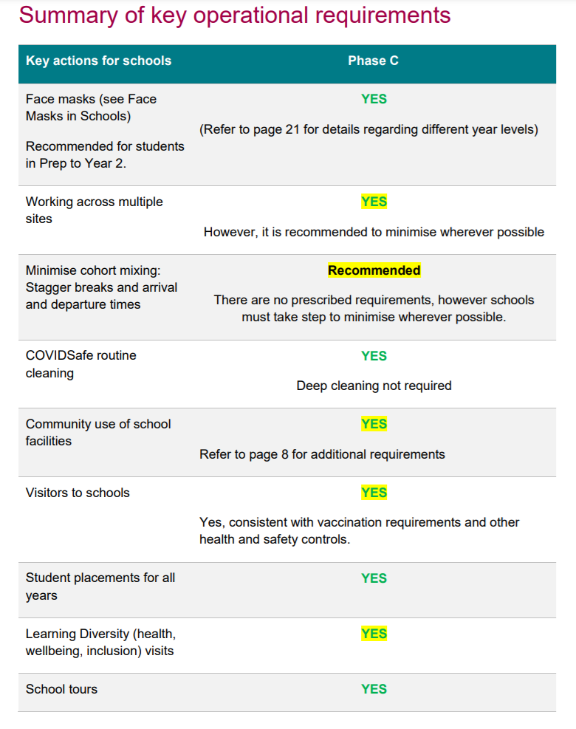

All Victorian students will return to full onsite learning from Monday 1 November. A permit is no longer required for those moving between metropolitan Melbourne and regional Victoria for the purpose of permitted education.
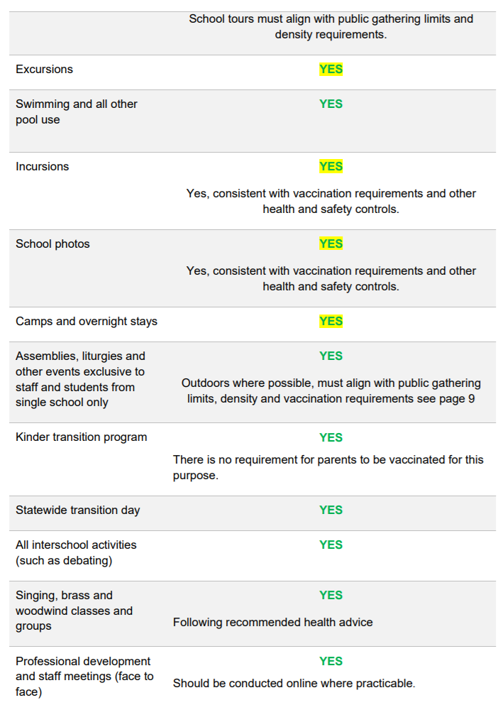
All information contained within the Summary of Key Operational Requirements taken from the School Operations Guide dated 1 November 2021.

